# **Enabling Event Hubs Capture**

This demo is to enable the event hubs capture. Azure Event Hubs Capture enables you to automatically deliver the streaming data in Event Hubs to an Azure Blob storage or Azure Data Lake Store account of your choice, with the added flexibility of specifying a time or size interval. Setting up Capture is fast, there are no administrative costs to run it, and it scales automatically with Event Hubs throughput units. Event Hubs Capture is the easiest way to load streaming data into Azure and enables you to focus on data processing rather than on data capture.

Event Hubs Capture enables you to process real-time and batch-based pipelines on the same stream. This means you can build solutions that grow with your needs over time. Whether you're building batch-based systems today with an eye towards future real-time processing, or you want to add an efficient cold path to an existing real-time solution, Event Hubs Capture makes working with streaming data easier.

To enable the event hubs capture, go the event hub that you have created and go to **Capture** menu at the left. Then click the **On** button and choose the **Capture Provider** as **Azure Storage**. Then click on select container to choose a storage account.

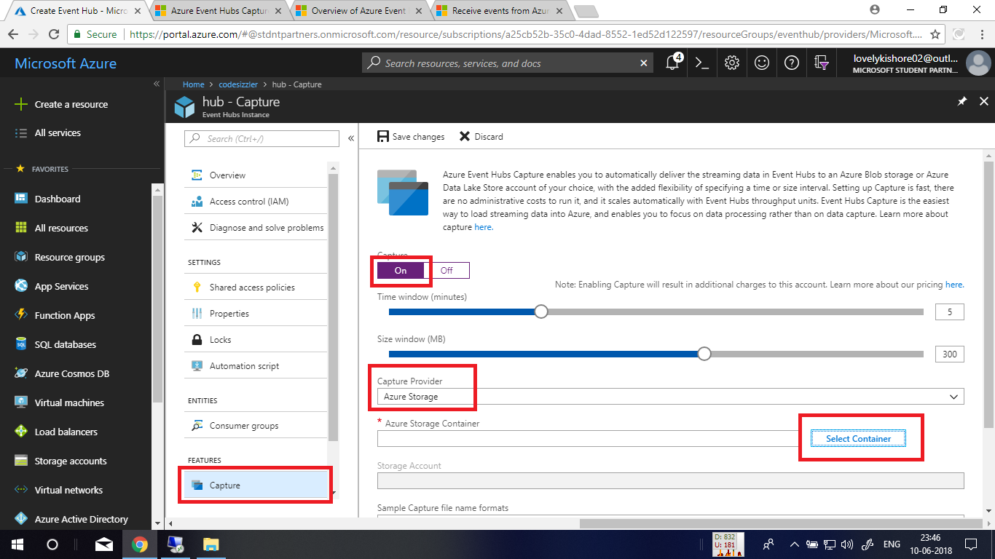

Next, click on the storage account. If you don’t have one, go through previous demos. After that, select an available container or click on **+ Container** to create a container to store the captured events.

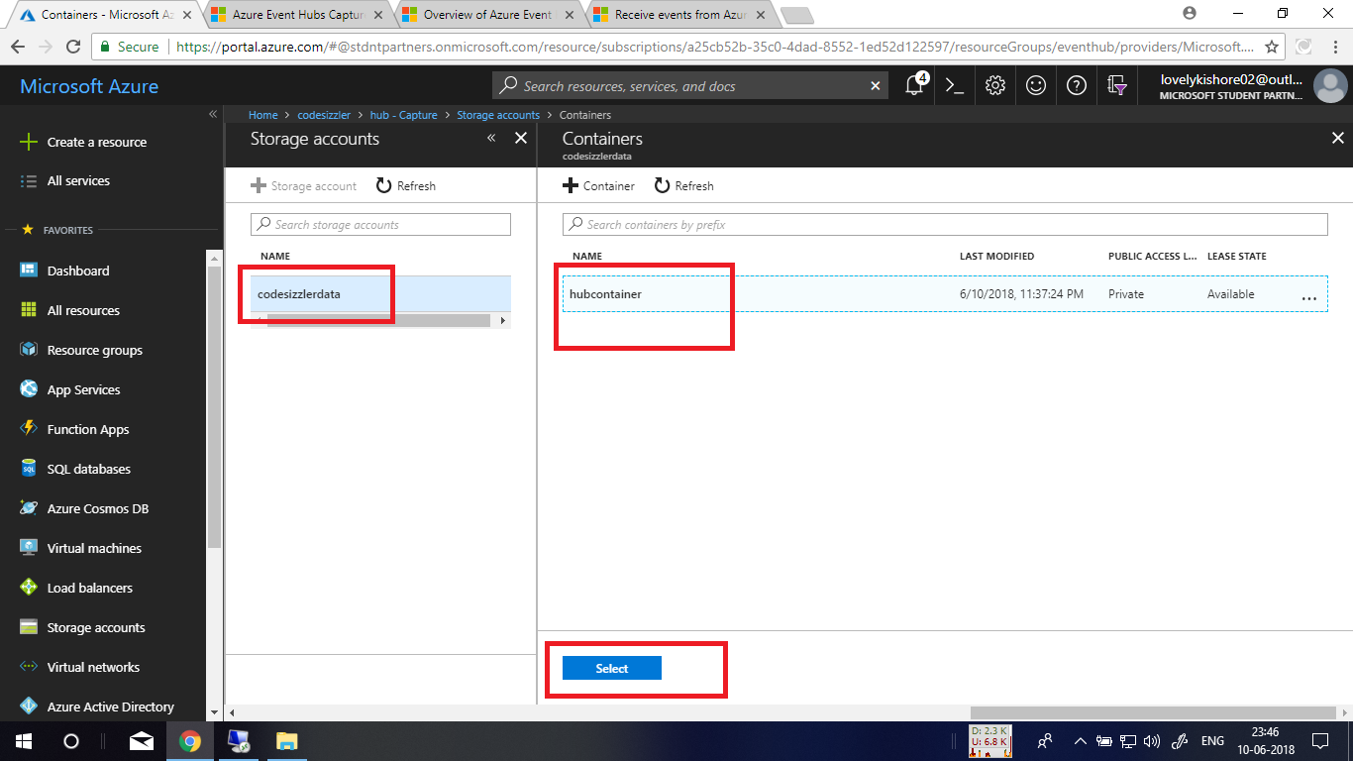

After choosing the storage account and the container, click on the **Save Changes** button. This will enable event capturing and will be storing the events in the container.

